Software Design Document
Gym Management System
(FitTrack)



Submitted by
Muhammad Abdullah S23BSEEN1M01073

Submitted to
Prof. Sir Zaman Ali

Department of Information Technology
Faculty of Computing
The Islamia University of Bahawalpur

Summary
The Software Design Document (SDD) for FitTrack outlines the technical framework and design strategies for developing a comprehensive fitness tracking platform. FitTrack aims to help users monitor their physical activity, set goals, track progress, and maintain a healthy lifestyle. The document describes the system architecture, which employs a client-server model to ensure smooth interaction between front-end interfaces and back-end services. It outlines modular design elements for features such as user authentication, activity tracking, personalized fitness plans, goal setting, and performance analytics.The platform will prioritize security by integrating secure technologies and protocols to protect user data, including health-related information. The design also focuses on scalability to handle a growing user base and performance optimization to ensure quick, responsive user interactions. The database structure will efficiently manage user profiles, activity logs, fitness plans, and progress data, with API integrations to enable third-party health devices and services.This SDD serves as a guide to ensure the successful implementation of the FitTrack platform, aligning with both functional requirements (fitness tracking features) and non-functional requirements (scalability, security, and performance).

Table of Content

1 Application Architecture for FitTrack 3
2 Controllers (Django Views and Business Logic) 5
2.1 APIs and External Libraries 5
2.2 External APIs and Libraries 5
3 Data Model Schema 6
3.1 User 6
3.2 Activity 6
3.3 Goal 7
3.4 Subscription 7
3.5 Progress 7
4 Data Flow Diagram (DFD) 9
9
5 User Interface 9
5.1 Design Philosophy 10
5.2 List of Screens/Pages 10
5.2.1 Home Page 10
5.2.2 Registration Page 11
5.2.3 Login Page 11
5.2.4 Dashboard 11
5.2.5 Activity Logging Page 11
5.2.6 Subscription Page 12
5.2.7 Cart Page 12
5.2.8 Category Page 12

Application Architecture for FitTrack
TheFitTrack application utilizes the Model-View-Template (MVT) architectural pattern, which is native to Django. This design pattern ensures a separation of concerns and allows for a scalable, maintainable, and extensible application structure. Below is a detailed explanation of the architecture components and their respective responsibilities:

1.1 Models
In Django, Models represent the data structure of the application and encapsulate business logic. They interact directly with the database to perform CRUD (Create, Read, Update, Delete) operations.
The key models in FitTrack include:
- User: Represents the users of the platform (e.g., athletes, coaches, fitness enthusiasts).
  - Attributes: name, email, password (hashed), role (e.g., athlete, coach), fitness goals, subscription status.
- Activity: Tracks physical activities performed by users, such as running, walking, or cycling.
  - Attributes: activity type, duration, calories burned, date, user (foreign key).
- Goal: Represents a fitness goal set by a user, such as achieving a target weight, running a specific distance, or burning a set number of calories.
  - Attributes: goal type, target value, current progress, status (active or completed), user (foreign key).
- Subscription: Stores subscription details for users, such as free or premium plan status.
  - Attributes: plan type (e.g., free, premium), start date, end date, user (foreign key).
- Progress: Tracks the progress of a user towards their set fitness goals based on logged activities.
  - Attributes: goal (foreign key), user (foreign key), progress metrics (steps, calories burned, etc.).

1.2 Views
Views in Django control the logic of handling requests and returning responses. They serve as intermediaries between the user interface (UI) and the data model. In FitTrack, views will handle user interactions, fitness activity logging, goal tracking, and subscription management.
The primary views in FitTrack include:
- User Dashboard View: Displays a summary of the user’s fitness activities, goals, and progress.
- Activity Tracking View: Allows users to log their activities, such as steps walked, calories burned, or workouts performed.
- Goal Setting View: Lets users define and manage their fitness goals, such as weight loss or achieving a certain number of steps.
- Subscription Management View: Allows users to subscribe to premium plans and manage their subscription preferences.
- Progress Report View: Displays the user’s progress towards their goals, including metrics and visualizations like charts or graphs.

1.3 Templates
Templates in Django define the structure of the HTML pages and represent the view layer. These templates are used to render dynamic content that is passed from the views. For FitTrack, the templates will be responsible for presenting the data, such as user dashboards, activity logs, and progress reports, in an intuitive and user-friendly way.
Some common templates in theFitTrack platform include:
- User Dashboard Template: Displays user information, a summary of their activities, and progress toward goals.
- Activity Log Template: Displays a form for users to log physical activities, as well as a list of previously logged activities.
- Goal Setting Template: Displays forms and data for setting and tracking fitness goals.
- Subscription Management Template: Provides an interface to manage subscription plans and view payment history.

Controllers (Django Views and Business Logic)
In Django, the Views can also serve as controllers, handling user input, interacting with the models, and returning responses (such as HTML pages or JSON data). The main controllers in FitTrack are responsible for the following:
- AuthController: Handles user authentication, including registration, login, and logout functionality. It will also manage user sessions and tokens (for REST APIs).
- ActivityController: Manages the logging and retrieval of activities. This includes adding new activities, updating them, or deleting them from the user’s activity log.
- GoalController: Responsible for managing the creation, updating, and tracking of fitness goals. It calculates progress and compares the current metrics to the target values.
- SubscriptionController: Manages the subscription plans, allowing users to subscribe to premium content, renew subscriptions, or cancel their plans.
- ProgressController: Retrieves and calculates the progress of users toward their fitness goals. It aggregates data from activities and presents the progress in a meaningful way.

APIs and External Libraries
Internal APIs: The internal APIs will handle key functionality such as user management, fitness activity logging, subscription handling, and progress tracking. These will facilitate secure communication between the front end and back end.

External APIs and Libraries
- Payment Gateway API: Integrates with third-party payment systems (e.g., Stripe, PayPal) to handle subscription payments.
- Fitness Device Integration API: Syncs data from fitness devices (e.g., Fitbit, Apple Health) to track user activities.
- Email Service API: Sends notifications and alerts to users about their activities, subscription status, and goals (e.g., SendGrid, Mailgun).
- Data Visualization Libraries: Tools like Chart.js or D3.js can be used for generating dynamic progress charts and reports.

The application includes internal APIs for managing user authentication, book operations, subscription handling, and revenue tracking. These APIs ensure secure communication between the front end and back end.

Data Model Schema
The Data Model Schema defines the database structure, the relationships between entities, and how data will be stored and accessed efficiently. Below is an outline of the key entities, their attributes, and relationships for the FitTrackapplication:

Entities and Their Attributes

User
Attributes:
- user_id (Primary Key): Unique identifier for each user.
- name: Full name of the user.
- email: Unique email address for authentication.
- password: Hashed password for authentication.
- role: Role of the user (e.g., "athlete," "coach").
- fitness_goals: JSON field storing user-specific fitness goals.
- created_at: Date and time of registration.
- updated_at: Date and time of the last update.

Relationships:
- One-to-Many relationship with Activity(a user can log multiple activities).
- One-to-Many relationship with Goal(a user can set multiple goals).
- One-to-One relationship with Subscription (each user has one subscription).

Activity
Attributes:
- activity_id (Primary Key): Unique identifier for each activity.
- user_id (Foreign Key): Links the activity to a specific user.
- activity_type: Type of activity (e.g., running, cycling).
- duration: Duration of the activity in minutes.
- calories_burned: Amount of calories burned during the activity.
- date: Date and time of the activity.
Relationships:
- Many-to-One relationship with User (each activity is associated with a user).
- Many-to-Many relationship with Goal (activities contribute to goal progress).

Goal
Attributes:
- goal_id (Primary Key): Unique identifier for each goal.
- user_id (Foreign Key): The user who set the goal.
- goal_type: Type of goal (e.g., weight loss, steps per day).
- target_value: The target for the goal (e.g., 10,000 steps).
- current_value: The current progress made towards the goal.
- status: Current status of the goal (e.g., "active," "completed").
Relationships:
- Many-to-One relationship with User (a goal is set by a user).
- Many-to-Many relationship with Activity (activities contribute to goal progress).

Subscription
Attributes:
- subscription_id (Primary Key): Unique identifier for each subscription.
- user_id (Foreign Key): The user who holds the subscription.
- plan_type: Type of subscription (e.g., "basic," "premium").
- start_date: Subscription start date.
- end_date: Subscription end date.
- status: Current status (e.g., "active," "expired").
Relationships:
- Many-to-One relationship with User (each user has one subscription).

Progress
Attributes:
- progress_id (Primary Key): Unique identifier for each progress record.
- user_id (Foreign Key): User associated with the progress.
- goal_id (Foreign Key): Goal associated with the progress.
- metric: Metric of progress (e.g., steps taken, calories burned).
- value: The progress value towards the goal.
Relationships:
- Many-to-One relationship with User (progress is linked to a user).
- Many-to-One relationship with Goal(progress is linked to a goal).
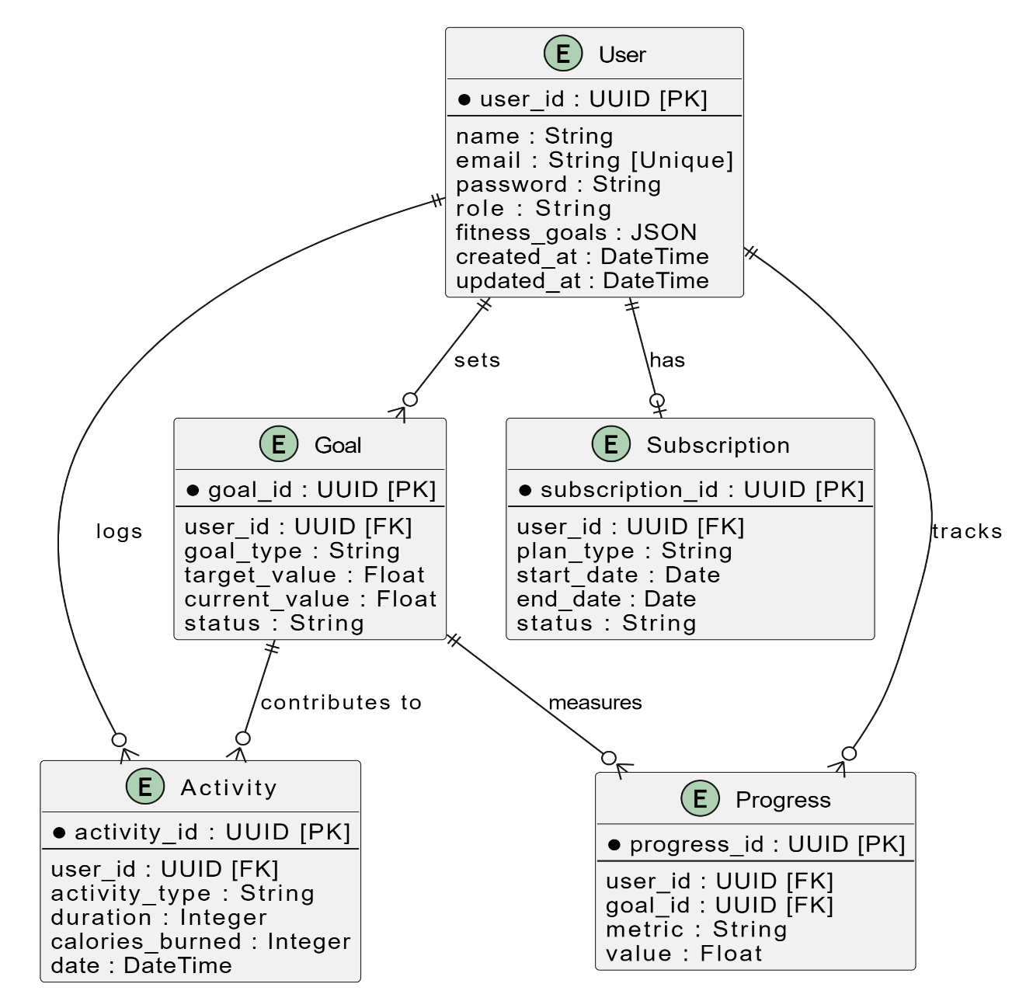
Entity Relationship Diagram:

Description
This ER diagram represents the FitTrack application's database structure. It includes five main entities: "User," which serves as the core entity linking all data; "Activity," which logs user activities like exercises; "Goal," which tracks user fitness objectives; "Subscription," which manages user subscription plans; and "Progress," which measures achievements towards goals. Relationships between entities are clearly defined to ensure efficient data organization and retrieval.

Data Flow Diagram (DFD)
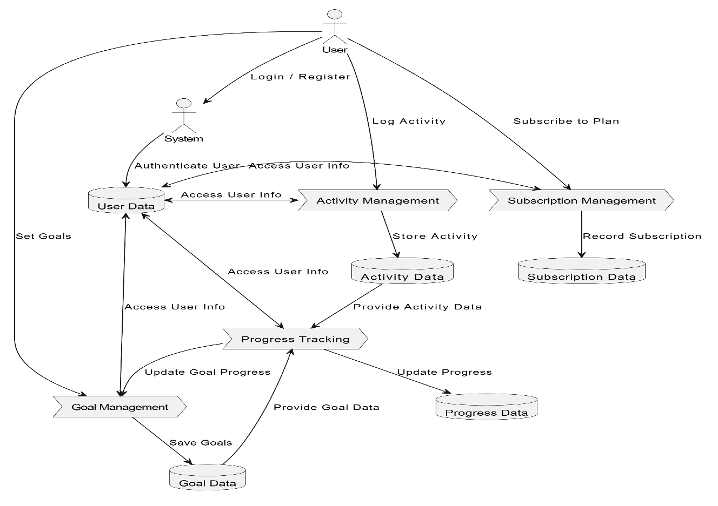

Description:
This DFD UML diagram illustrates a system where a user interacts with modules for activity management, goal setting, subscription management, and progress tracking. The user logs in or registers, and the system authenticates them using the user data database. Activities are logged and stored in the activity database, while goals are set and saved in the goal database. Subscriptions are managed and recorded in the subscription database. The progress tracking module updates progress by accessing data from activity, goal, and progress databases, ensuring seamless integration and dynamic goal updates.

Interface

DashBoard

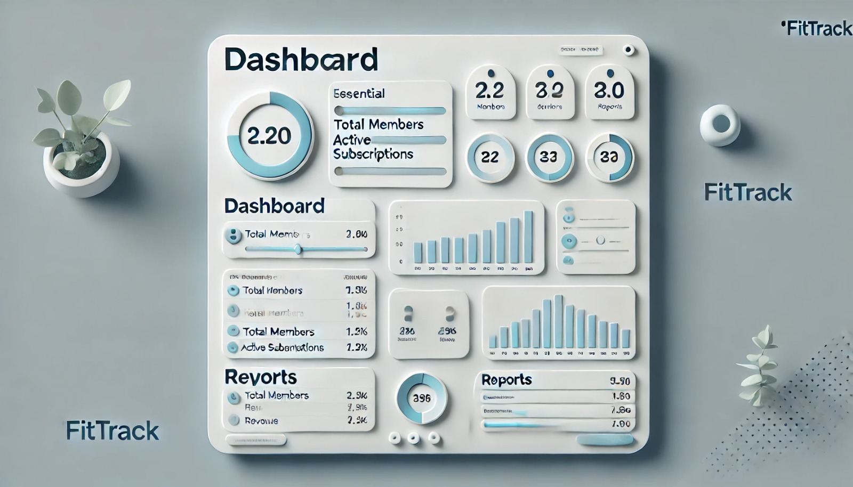

Login Page

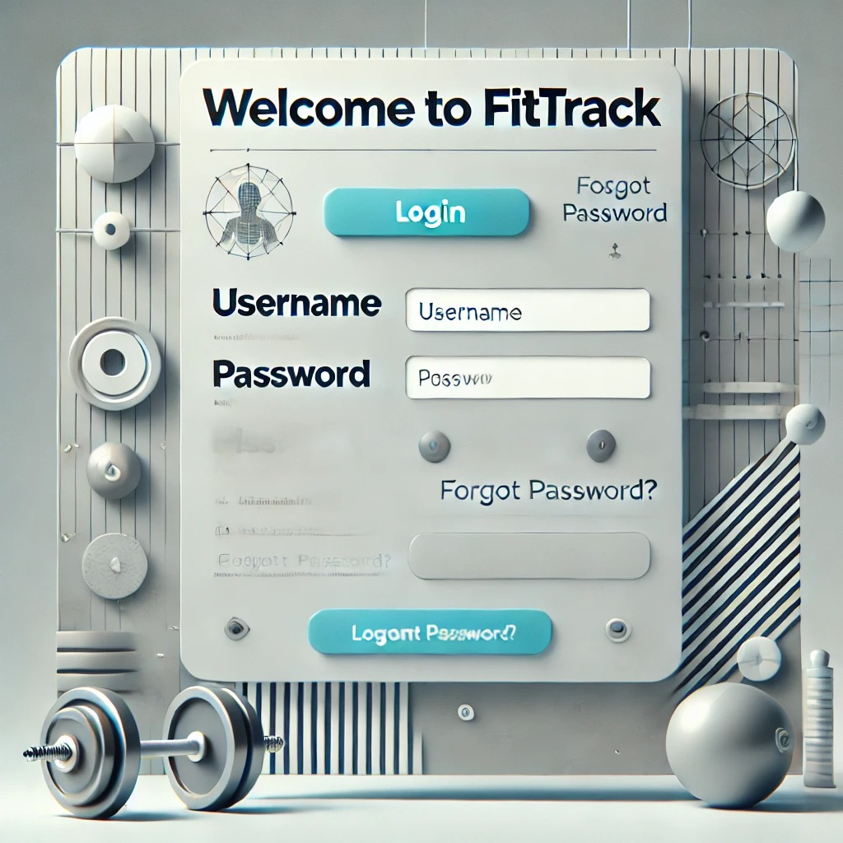

User Interface
TheFitTrack application UI is designed to provide users with an intuitive, engaging, and efficient experience while maintaining a modern and clean aesthetic. The interface balances ease of use with functionality, making it easy for both athletes and coaches to track progress, set goals, and manage subscriptions.

Design Philosophy

Color Scheme
- Primary Color: Teal (#008080) – Represents health, wellness, and vitality, which resonates with the fitness goals of the users.
- Secondary Color: Orange (#FFA500) – Evokes energy, motivation, and enthusiasm, fitting for a fitness platform.
- Neutral Shades: Light Gray (#F0F0F0) for backgrounds and Dark Gray (#333333) for text, ensuring good contrast and readability.
- Accent Color: Green (#28a745) – Used for call-to-action buttons and progress indicators, symbolizing success and achievement.

Typography
- Primary Font: Poppins – A clean, modern, sans-serif font that enhances readability across the platform.
- Secondary Font: Playfair Display – Used for headings to provide a sophisticated and elegant feel, creating contrast with the body text.

Design Niche
- Minimalistic and Modern: Focuses on essential elements and smooth user navigation without overwhelming the user.
- Rounded Corners and Soft Shadows: These design elements create a clean, approachable, and contemporary look.
- User-Centric Layout: Prioritizes user tasks such as logging activities, setting goals, and tracking progress.

Responsiveness
- Targeted Screen Sizes:
  - Desktop: 1200px and above.
  - Mobile: 320px to 767px.
- The application adopts a mobile-first approach, ensuring a seamless experience on both small and large screens.

List of Screens/Pages

Home Page
- Purpose: Welcome users, provide navigation options, and highlight trending activities or top fitness challenges.
- Controls and Data:
  - Search Bar: Allows users to search for activities, coaches, or challenges.
  - Navbar: Contains logo, activity categories (e.g., Running, Cycling), and profile link.
  - Footer: Includes contact details, privacy policy, and social media links.
  - Featured Section: Displays top fitness challenges, trending activities, or new workouts.
- Input Constraints:
  - Search Bar: Accepts alphanumeric input with no special characters.

Registration Page
- Purpose: Enable new users (athletes or coaches) to create an account.
- Controls and Data:
  - Textboxes:
    - Name (Alphanumeric input only, max 50 characters).
    - Email (Valid email format).
    - Password (Minimum 8 characters, must include at least one number and one special character).
  - Dropdown: Select user role ("Athlete" or "Coach").
  - Button: "Register" (Disabled until all inputs are valid).
- Input Constraints:
  - Email: Must be a valid email format.
  - Password: Must meet minimum length and include at least one special character.

Login Page
- Purpose: Allow registered users to log in to their account.
- Controls and Data:
  - Textboxes:
    - Email (Valid email format).
    - Password
  - Button: "Login."
- Input Constraints:
  - Email: Must follow valid email format.
  - Password: Must be a minimum of 8 characters.

Dashboard
- Purpose: Provide users with an overview of their fitness data, goals, and activities.
- Controls and Data:
  - Navigation Links: Quick access to key features like "Track Activity," "Set Goals," "Profile," and "Progress."
  - Cards: Display summaries such as total steps, calories burned, or active challenges.
  - Progress Visualizations: Graphs or charts showing user progress towards fitness goals.
- Input Constraints: No user input required on this page; data is dynamically generated based on user activity and goals.

Activity Logging Page
- Purpose: Allows athletes to log their daily activities (e.g., running, cycling, weightlifting).
- Controls and Data:
  - Textboxes:
    - Activity Type (e.g., Running, Walking).
    - Duration (in minutes).
    - Calories Burned (calculated based on activity type and user data).
  - Button: "Log Activity."
- Input Constraints:
  - Activity Type: Must be selected from a predefined list of activities.
  - Duration: Numeric input, must be a positive integer.

Subscription Page
- Purpose: Manage and purchase subscriptions for premium content or features.
- Controls and Data:
  - Radio Buttons: Select subscription type ("Monthly").
  - Button: "Subscribe."
  - Subscription Summary: Displays current plan and renewal date.
- Input Constraints:
  - Payment fields validated for numeric and secure inputs (e.g., credit card number, billing information).

Cart Page
- Purpose: Displays a list of products (e.g., premium fitness plans or coaching services) that the user has added to their cart for purchase.
- Controls and Data:
  - Product List:
    - Name, Price, and Thumbnail of each item.
    - Quantity selector (for recurring services).
  - Price Summary:
    - Subtotal, discount (if applicable), and total amount.
  - Buttons:
    - "Remove" (to delete an item).
    - "Proceed to Payment" (navigates to the payment page).
- Input Constraints:
  - Quantity: Numeric input limited to available stock.

Category Page
- Purpose: Display categories of available fitness activities or challenges to help users explore content.
- Controls and Data:
  - Category List:
    - Grid or card-based layout showing categories like Running, Yoga, Strength Training, etc.
    - Category icons or images.
    - Category names with a count of available challenges.
  - Button: "View Challenges" (navigates to a filtered list of activities within the selected category).

Profile Page
- Purpose: Allow users to manage their account details, preferences, and subscriptions.
- Controls and Data:
  - Profile Information:
    - Name, Email, Role, and Subscription Status.
    - Editable fields for Name and Email.
  - Buttons:
    - "Edit Profile" (opens editable text fields).
    - "Change Password" (navigates to a password change form).
    - "Logout" (logs the user out).
  - Subscription Management:
    - Displays active subscription details (e.g., type, start date, and end date).
    - Button: "Renew Subscription" (if applicable).

